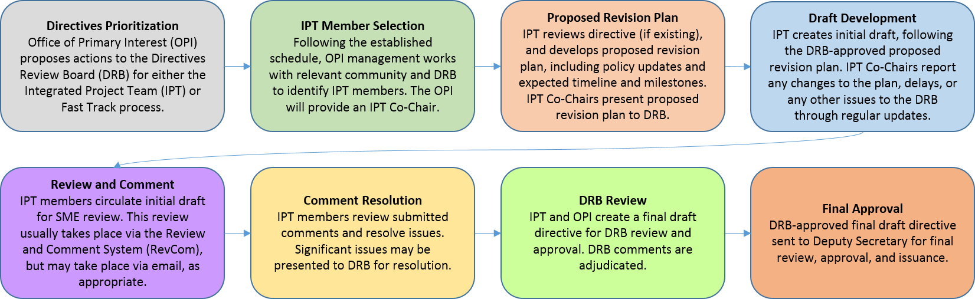
Attendees
IPT members:
Name | Title | Present
Sylvia Chavez/Sandia | Planning & Ops Specialist | X
Cindy Farinholt/Nevada Field Office MSTS | Principal S&S Specialist | x
Jules Martinez/Brookhaven Natl Lab | Security Operations Manager
Chad Bourgoin/DOE HQ | Environmental Manager/Alt HSO
SMEs or other guests:
Crystal Banken/Y-12 | Personnel Security Supervisor | X
Celia Mauro | Personnel & Info Sec Supervisor
Karrie Williams | Personnel Security Specialist 3 | X
Mark Wetherby | Personnel Security Dir/Y-12

Agenda:
Action Items/Deliverables/Next Steps:
Action | Responsible Member(s) | Expected Completion
Review discussion & show revised V5 with team members | ALL | today
Full IPT discussion tomorrow 10/11/23 will provide upcoming deliverable dates to communicate to the team | Sylvia/Chad/Cindy
Determined to keep these meetings on calendars & cancel as needed for Oct/Nov/Dec | ALL | 10/10/2023

Next meeting: 10/17/2023

