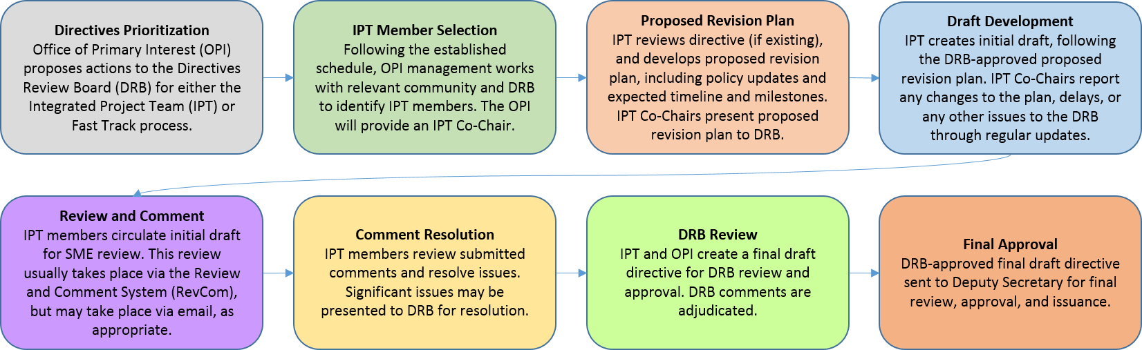
Attendees
IPT members:
Name | Title | Present
Sylvia Chavez/Sandia | Planning & Ops Specialist | X
Cindy Farinholt/Nevada Field Office MSTS | Principal S&S Specialist | x
Jules Martinez/Brookhaven Natl Lab | Security Operations Manager
Chad Bourgoin/DOE HQ | Environmental Manager/Alt HSO | x
SMEs or other guests:
Crystal Banken/Y-12 | Personnel Security Supervisor | X
Celia Mauro | Personnel & Info Sec Supervisor | X
Karrie Williams | Personnel Security Specialist 3 | X
Mark Wetherby | Personnel Security Dir/Y-12

Agenda:
Action Items/Deliverables/Next Steps:
Action | Responsible Member(s) | Expected Completion
Meeting with Mark Hojnake (DOE HQ) & Kevin Webber (IPT Chair) to discuss the Security Awareness V4 changes vs. the version they sent out after the Germantown meeting | Sylvia Chavez/Cindy Farinholt/Chad Bourgoin | 10/04/2023
Review our comment resolution sheets to narrow our down our biggest discussion points | ALL | today
Send out email to IPT Team members & SMEs after the 10/4 meeting | Sylvia | 10/6/2023
Review Mark/Kevin/Awareness team discussion | ALL | 10/10/2023

Next meeting: 10/09/2023

