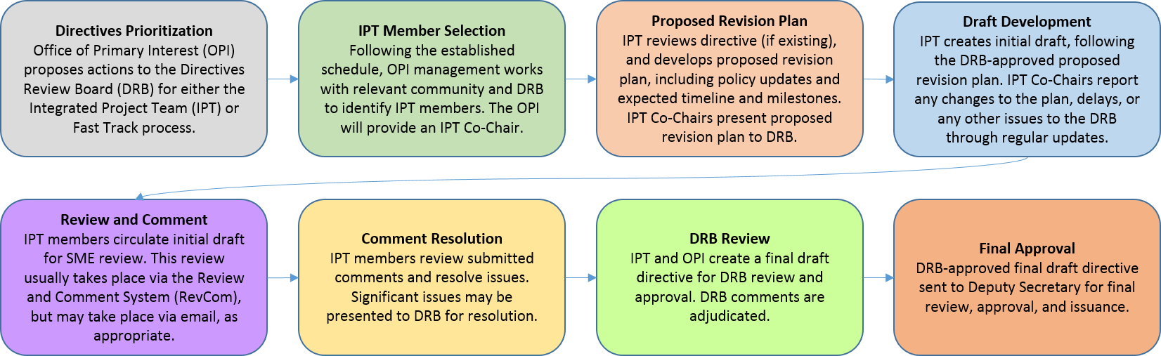
Attendees
IPT members:
Name | Title | Present
Sylvia Chavez/Sandia | Planning & Ops Specialist | X
Cindy Farinholt/Nevada Field Office MSTS | Principal S&S Specialist | x
Jules Martinez/Brookhaven Natl Lab | Security Operations Manager
Chad Bourgoin/DOE HQ | Environmental Manager/Alt HSO | x
SMEs or other guests:
Crystal Banken/Y-12 | Personnel Security Supervisor
Celia Mauro | Personnel & Info Sec Supervisor
Karrie Williams | Personnel Security Specialist 3
Mark Wetherby | Personnel Security Dir/Y-12

Agenda:
Action Items/Deliverables/Next Steps:
Action | Responsible Member(s) | Expected Completion
We provided a comment resolution sheet to the Co-chairs with our fixes for the V4 | Sylvia Chavez | 8/31
Waiting for answers from Kevin in response to our comment resolution sheet | Sylvia | 9/5
We’ll set up a meeting with everyone & co-chairs

