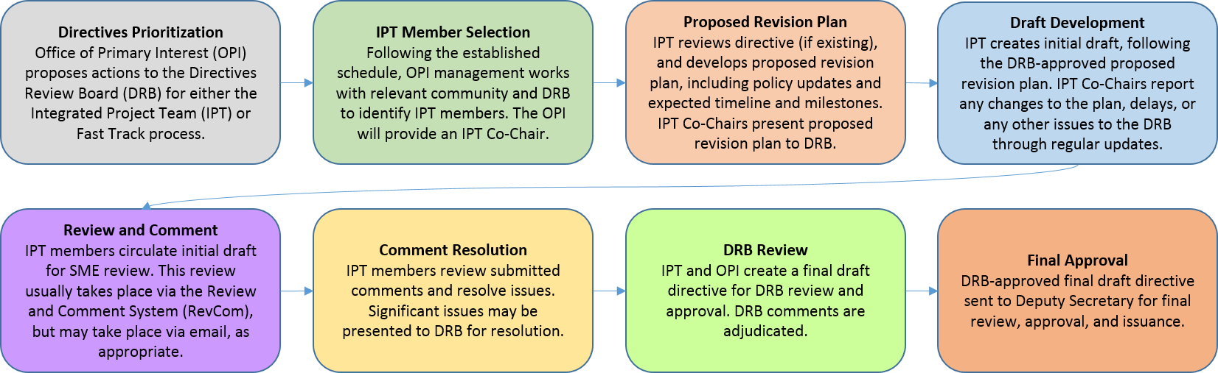
Attendees
IPT members:
Name | Title | Present
Sylvia Chavez/Sandia | Planning & Ops Specialist | X
Cindy Farinholt/Nevada Field Office MSTS | Principal S&S Specialist | x
Jules Martinez/Brookhaven Natl Lab | Security Operations Manager
Chad Bourgoin/DOE HQ | Environmental Manager/Alt HSO | x
SMEs or other guests:
Crystal Banken/Y-12 | Personnel Security Supervisor | x
Celia Mauro | Personnel & Info Sec Supervisor | x
Karrie Williams | Personnel Security Specialist 3 | x
Mark Wetherby | Personnel Security Dir/Y-12

Agenda:
Action Items/Deliverables/Next Steps:
Action | Responsible Member(s) | Expected Completion
IPT Cross Team FED REQS. Review both sections& put comments in REVCOM sheet for the 7/17 meeting | IPT members | 7/11
If you are going to be out send your comments about Performance Assurance & Self Assessments by 7/17/23 COB | ALL | 7/17
Fed Requirements & Responsibilities | IPT Team Members | 7/17
Security Plans & Analysis/Security Awareness and provide feedback | ALL | 7/24
Ask John Fitzgibbons:  3. Define an individual/employee  DOE Fed employees  Contractor employees  Contractor individuals  472.2  CRD | ALL
Surveys & Self Assessments | ALL | 7/27
Sent out the REVCOM with GRAY lines for Awareness with no RESPONSE…..i added potential responses. We will review @ Team Meeting | ALL | 7/18
Finalize REVCOM with ACCEPT/REJECT/PARTIALLY ACCEPT to Co-chairs | Sylvia | 7/21
Based on our responses back. Update the DRAFT Order to incorporate ACCEPTED changes, review with TEAM on 8/1 and finalize and send to co-chairs. | Sylvia | 8/11
Add to your site’s background documents | Sylvia | 12/2023

DATES

- Comment Resolution Sheet Completion (Due 07/21/23) – There were many incomplete areas of the comment sheet mainly due to issues downloading the report. A two-week period will be provided to complete. Once the comment resolution sheet (attached) is completed, it will be consolidated and turn-around quickly for distribution to IPT SME/Stakeholders. I believe every team still has outstanding comments that need to be addressed, except S&S Training.
- Revised Draft Order (Due 08/11/23) – This revision will incorporate ALL changes made from the Comment Resolution Sheet (above), EHSS Review, and Integrated Team meetings. It is highly recommended that changes to your portion of the order be fluid and addressed throughout the various processes. I believe the last integrated-team meeting occurs the same week this is due.
- Co-Chair Crosswalk (08/15-17) – The Co-Chairs will be meeting in Germantown, MD to crosswalk the 08/11 Draft Planning Order and the most recent draft Program Management Order to identify any contradictions or areas of concern between the two documents. We will also be addressing action-items identified throughout the team meetings and doing a hard scrub of delegations and authorities. Anyone who is in the area or that can make it is welcome to participate.
- Final Review (08/21-25) – This will be the last opportunity to review changes made from the Co-Chair Crosswalk and review the product we plan to submit into Formal RevCom.
- Formal REVCOM – 08/30.

Color Key for Comment Resolution Sheet:
- Fed Requirements
- Security Plans & Analysis
- Performance Assurance Program
- Surveys and Self-Assessments
- Security Awareness
- Co-Chairs

