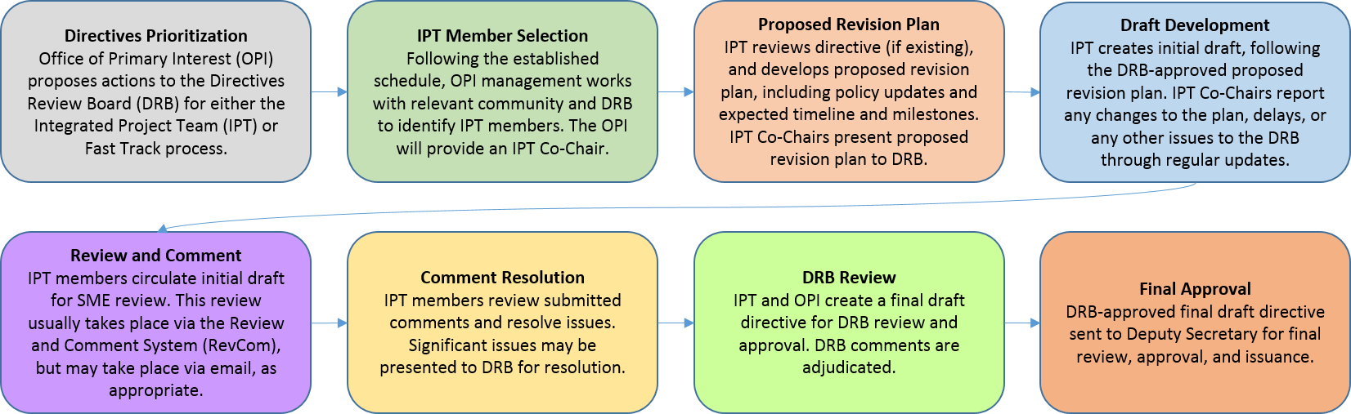
Attendees
IPT members:
Name | Title | Present
Sylvia Chavez/Sandia | Planning & Ops Specialist | X
Cindy Farinholt/Nevada Field Office MSTS | Principal S&S Specialist | X
Jules Martinez/Brookhaven Natl Lab | Security Operations Manager
Chad Bourgoin/DOE HQ | Environmental Manager/Alt HSO | X
SMEs or other guests:
Crystal Banken/Y-12 | Personnel Security Supervisor
Celia Mauro | Personnel & Info Sec Supervisor
Karrie Williams | Personnel Security Specialist 3 | X
Mark Wetherby | Personnel Security Dir/Y-12

Agenda:
Action Items/Deliverables/Next Steps:
Action | Responsible Member(s) | Expected Completion
IPT Cross Team meetings with other IPT Team Leads. Review both sections | ALL | 7/12/2023
Review revised redlined DRAFT (provided by IPT Co-chair) before meeting with SP&A | ALL | 7/11
Security Plans & Analysis/Security Awareness and provide feedback | ALL | 7/12
Ask John Fitzgibbons:  3. Define an individual/employee  DOE Fed employees  Contractor employees  Contractor individuals  472.2  CRD | ALL | 7/12
Add to your site’s background documents | Sylvia | 7/30

7/10-21 - EHSS 2nd review of our Order – areas that can be misinterpreted. Office is responding to policy clarifications to ensure parts that don’t provide level of detail to implement & provide feedbacks for those areas. For DOE HQ terminology

6/30 – 8/30 – meetings cross team – teams responsibilities to review the other parts of the order. Terminology, structure, contradictions, etc. co-chairs will attend for awareness of issues. We’ll eventually get to meet with all teams.

6/27 Meeting
Determined to wait until the revised REDLINE DRAFT is available to review SP&A section, prior to our cross-team meeting.
We’ll use the REVCOM sheet for the SP&A section to gather feedback.

7/11 We’ll review any new DRAFTS (review John F.s comments ACCEPTS & REJECTS
7/12 is our 1-hour cross-team meeting w/ SP&A (Tommy Zavala/Cindy Farinholt)

