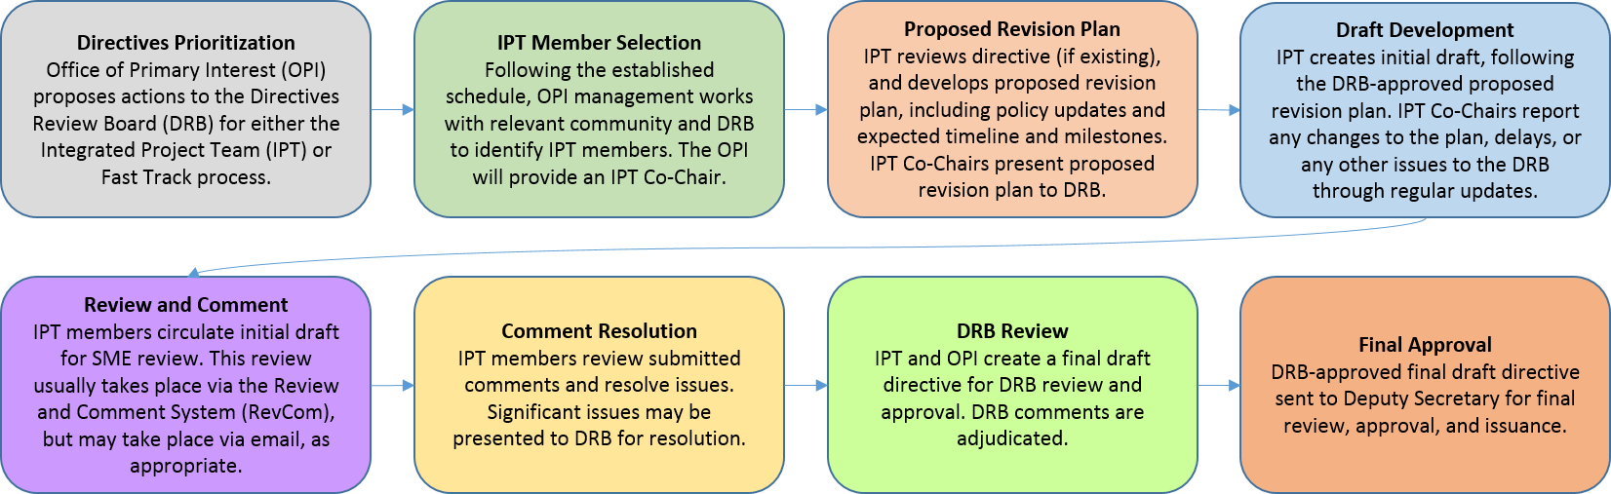
Attendees
IPT members:
Name | Title | Present
Sylvia Chavez/Sandia | Planning & Ops Specialist | X
Cindy Farinholt/Nevada Field Office MSTS | Principal S&S Specialist | X
Jules Martinez/Brookhaven Natl Lab | Security Operations Manager
Chad Bourgoin/DOE HQ | Environmental Manager/Alt HSO | X
SMEs or other guests:
Crystal Banken/Y-12 | Personnel Security Supervisor | X
Celia Mauro | Personnel & Info Sec Supervisor | X
Karrie Williams | Personnel Security Specialist 3 | X
Mark Wetherby | Personnel Security Dir/Y-12

Agenda:
Kevin.webber@hq.doe.gov replacing Cecelia Hunter as the Program Planning Co-chair effective 4/12/2023.
- Action Items/Deliverables/Next Steps:
Action | Responsible Member(s) | Expected Completion
Teams adjudicate the comments: Run & review REVCOM Report at each meeting to determine what comments haven’t been resolved | ALL | 6/23/2023
Team revised our DRAFT Order for official REVCOM | ALL | 6/30/23

2. Add feedback from SMEs/Stakeholders to REVCOM
Sylvia - 9 sheets that I’ve received with comments for us to review –
19 comments for Security Awareness portion.
23 all other subtopics that weren’t duplicates.

Time spent on reviewing 32 CFR 117.12, 32 CFR 2001, DOE 472.2A, DOE 470.4B based on comment from Rob Ambrose about DOE O 472.2A not referring to the Termination Briefing in the newly published Pers Sec Order.

Time spent on reviewing OPSEC/Critical Information Order (DOE O 471.6) to see if content or reference to DOE O 470.4B for initial, comp or annual briefings.
4. Use the REVCOM system to track each IPT members DRAFT comments/feedback into REVCOM and regardless of what area it is in.
I was able to run a Custom Report today. But I couldn’t see my comments, so not sure if I entered them correctly.
Go to section in the REVCOM and paste the comment from the resolution sheet. Put a note at the beginning to identify who made the comment. And click submit
REVCOM will allow us to print out feedback to help organize the feedback for our Security Awareness subtopic.
Reports: Custom, substantive, all orgs, no suborg, download spreadsheet identifies specific sections
Can’t upload spreadsheet back to REVCOM.
We have to copy the responses manually back into REVCOM
Download again with the resolutions and provide back to SMEs/Stakeholder.
I’m going to work with Sandia Team Leads and SMEs to put together feedback & comments to present to Sandia’s oversight
Lock down REVCOM by a certain date???? Tommy – will discuss & make a determination
IPT Team members are the only ones who can see REVCOM

Track & update DRAFT Order & that DRAFT order will be sent back to you at some time.

5/19 upload comments into PORTAL
5/22 – 6/23 to resolve comments
6/26 – 6/30- make accepted revisions into DRAFT Order
6/30 – 8/30 Completed excel sheets – consistent language (ACCEPT, PARTIALLY ACCEPT, REJECT) til 6/23
Updated DRAFTs to Reed Bickmore
6/30 – 8/30 EHSS 2nd review of our Order – areas that can be misinterpreted. Office is responding to policy clarifications to ensure parts that don’t provide level of detail to implement & provide feedbacks for those areas.

6/30 – 8/30 – meetings cross team – teams responsibilities to review the other parts of the order. Terminology, structure, contradictions, etc. co-chairs will attend for awareness of issues. We’ll eventually get to meet with all teams.

6/30-8/30 Planning co-chairs meet with the other IPT Program Management Operations co-chairs. Please identify things to look for in their order.

How do we plan on getting these back to the groups who commented?
Will the team leads be responsible for collecting & replying back to submitters?
Comment resolution sheets to co-chairs, redistribute to team leads to determine if they want to notify submitters of the ACCEPT, REJECT or PARTIALLY ACCEPT. At our discretion.

Add to your site’s background documents
FULL REPORT only respond to your area.
All comments will be consolidated to 1 sheet.

6/7/23
Integrated Team Meeting to other subtropical areas Team – discuss anomalies, inconsistencies with Team, Co-chair & team lead. July 10 – August 14.

6/21/23 Meeting
Terminology – hilite words we want advisement on: individuals, employees, contractors
Weekly meetings to review comments
33 comments – we’ve got about 4 left

By 6/23 due to co-chairs
REVCOM sheet

By 6/30
DRAFT CLEAN
REDLINE strike of DOE Order
All excel spreadsheets – to co-chairs with ACCEPT, REJECT, PARTIALLY ACCEPT by 6/30

7/10-21 EHSS 2nd review CLEAN DRAFT again For DOE HQ terminology

